**Preserving Rock Walls at Hamlets Reserve**

I attended the Hamlet Reserve site visit on November 1, 2024. Remnants of stone walls as well as corners/hearth of a possible homesite were present downslope to Wilkinson Creek, in the NW section of the property. These rock walls could be part of the old rural postal route network.

Years ago, I attended a presentation by a historian interested in old indigenous trading sites and trails in the Haw River area being used later as routes between Carrboro and Pittsboro. Comparing an 1807 Chatham County map of rural postal routes [Fig. A] and a current Google map [Fig. B] of the Hamlets Reserve area suggests that there may be some connection between the old rural postal routes and the existing stone walls present at Hamlets Reserve.

Registered historical homesites and cemeteries qualify as protected sites. However, I am not aware if there are any regulations or conditions for preserving or recording rural postal routes [or any other physical structures]. Can the existing rubble walls be retained? Approximate location: lots 15–17 and SCM [91; 8.77 acres]), in First Plat for Hamlets Reserve, <https://www.chathamcountync.gov/home/showpublisheddocument/70351/638651004515930000>?

Compare 1807 map [Fig. A.] of rural postal roads off Hamlet Chapel Road, near Wilkinson Creek, to Google map [Fig. B.].

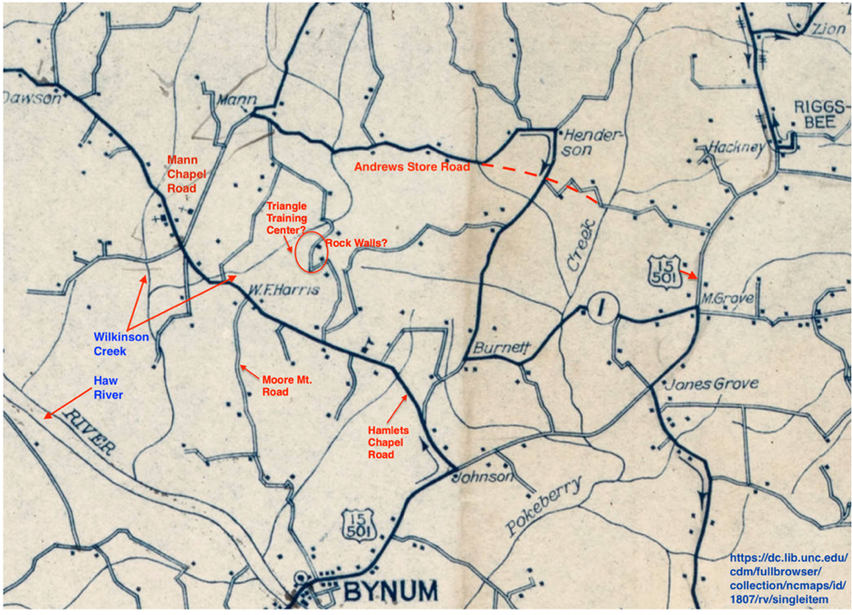

A. 1807 Rural Postal Routes map, Chatham County.

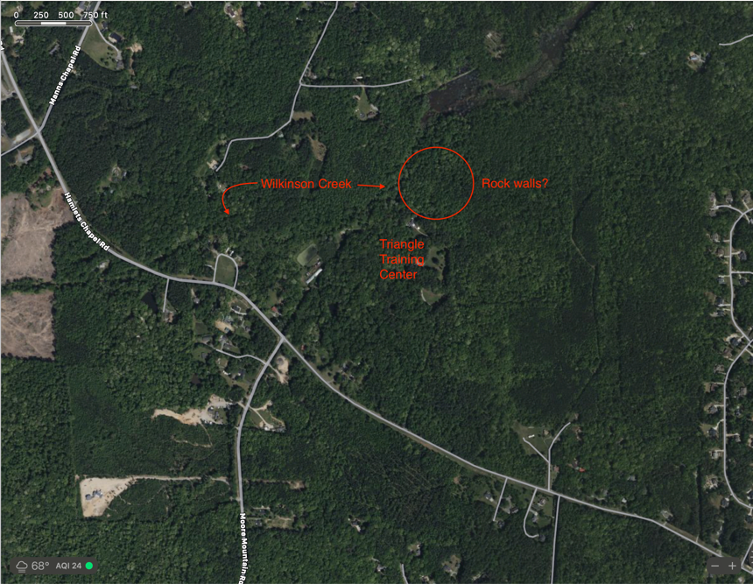

B. Goggle map.

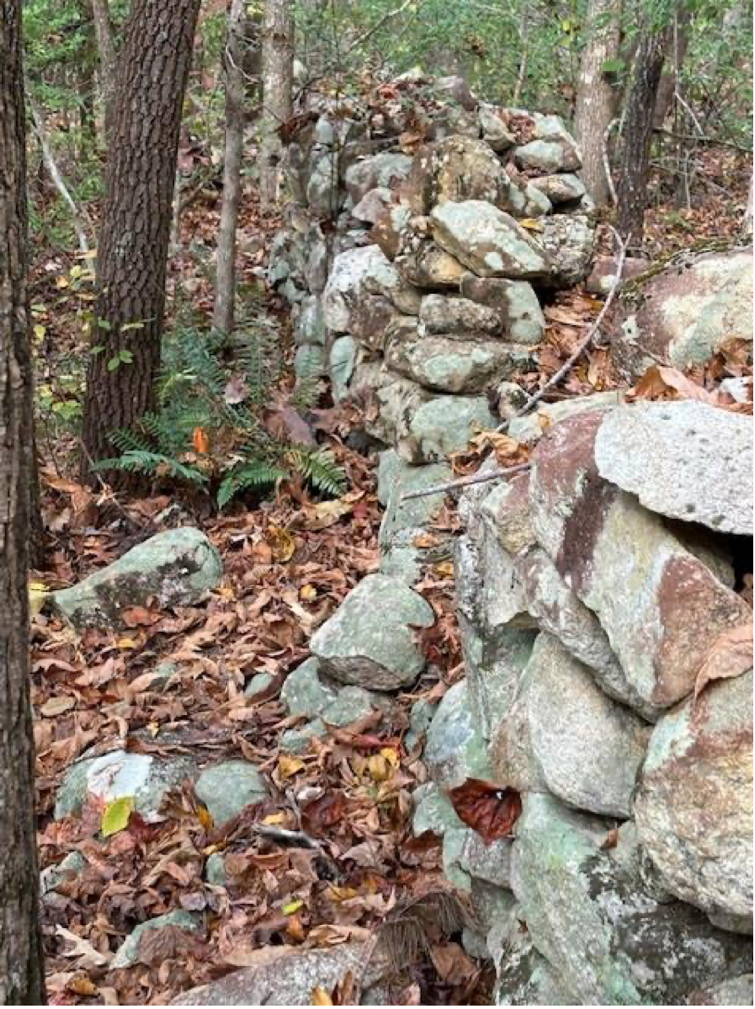 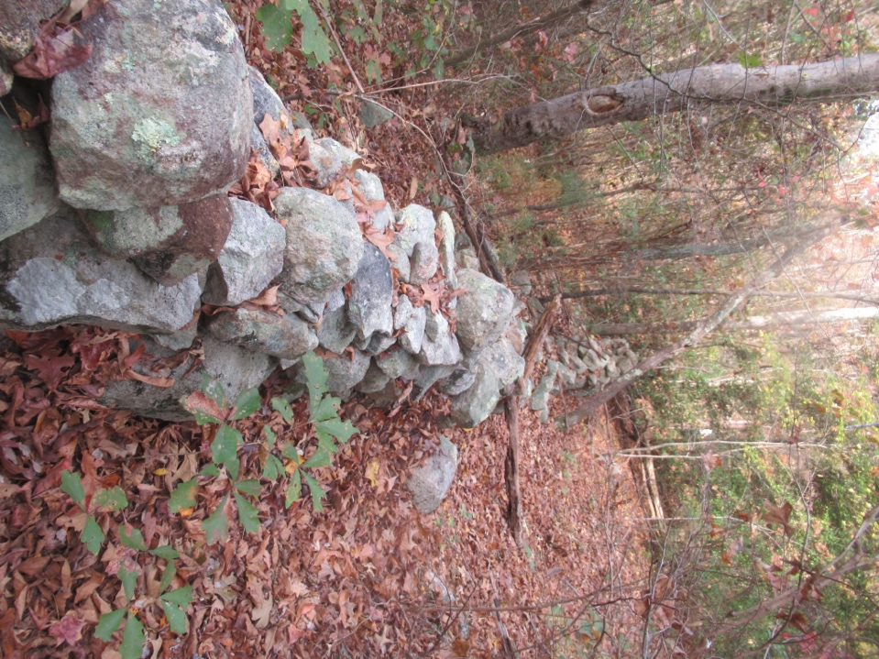

C. Rubble stone walls. [Credit: Kimberly Tyson] D. Rubble stone walls. [Credit: Jeannie Ambrose]

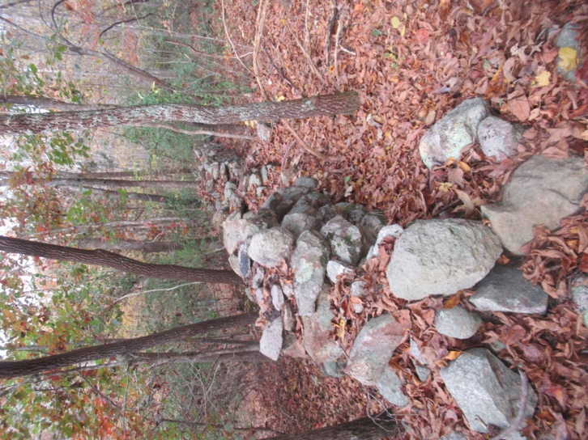 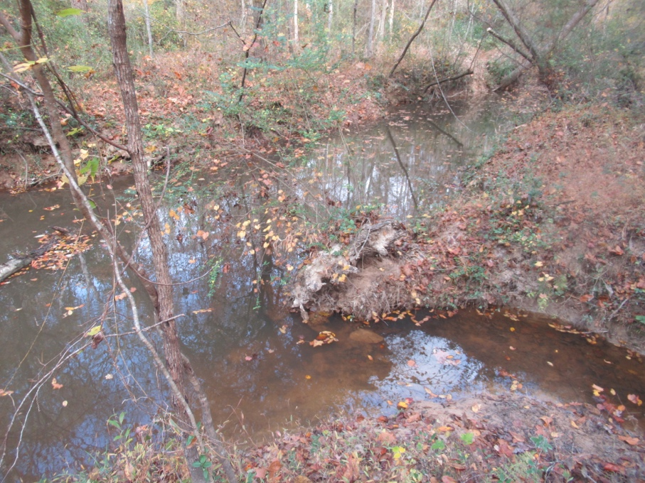

E. Rubble stone walls. F. Wilkinson Creek & unnamed creek. [Credit: Jeannie Ambrose]

[Credit: Jeannie Ambrose]