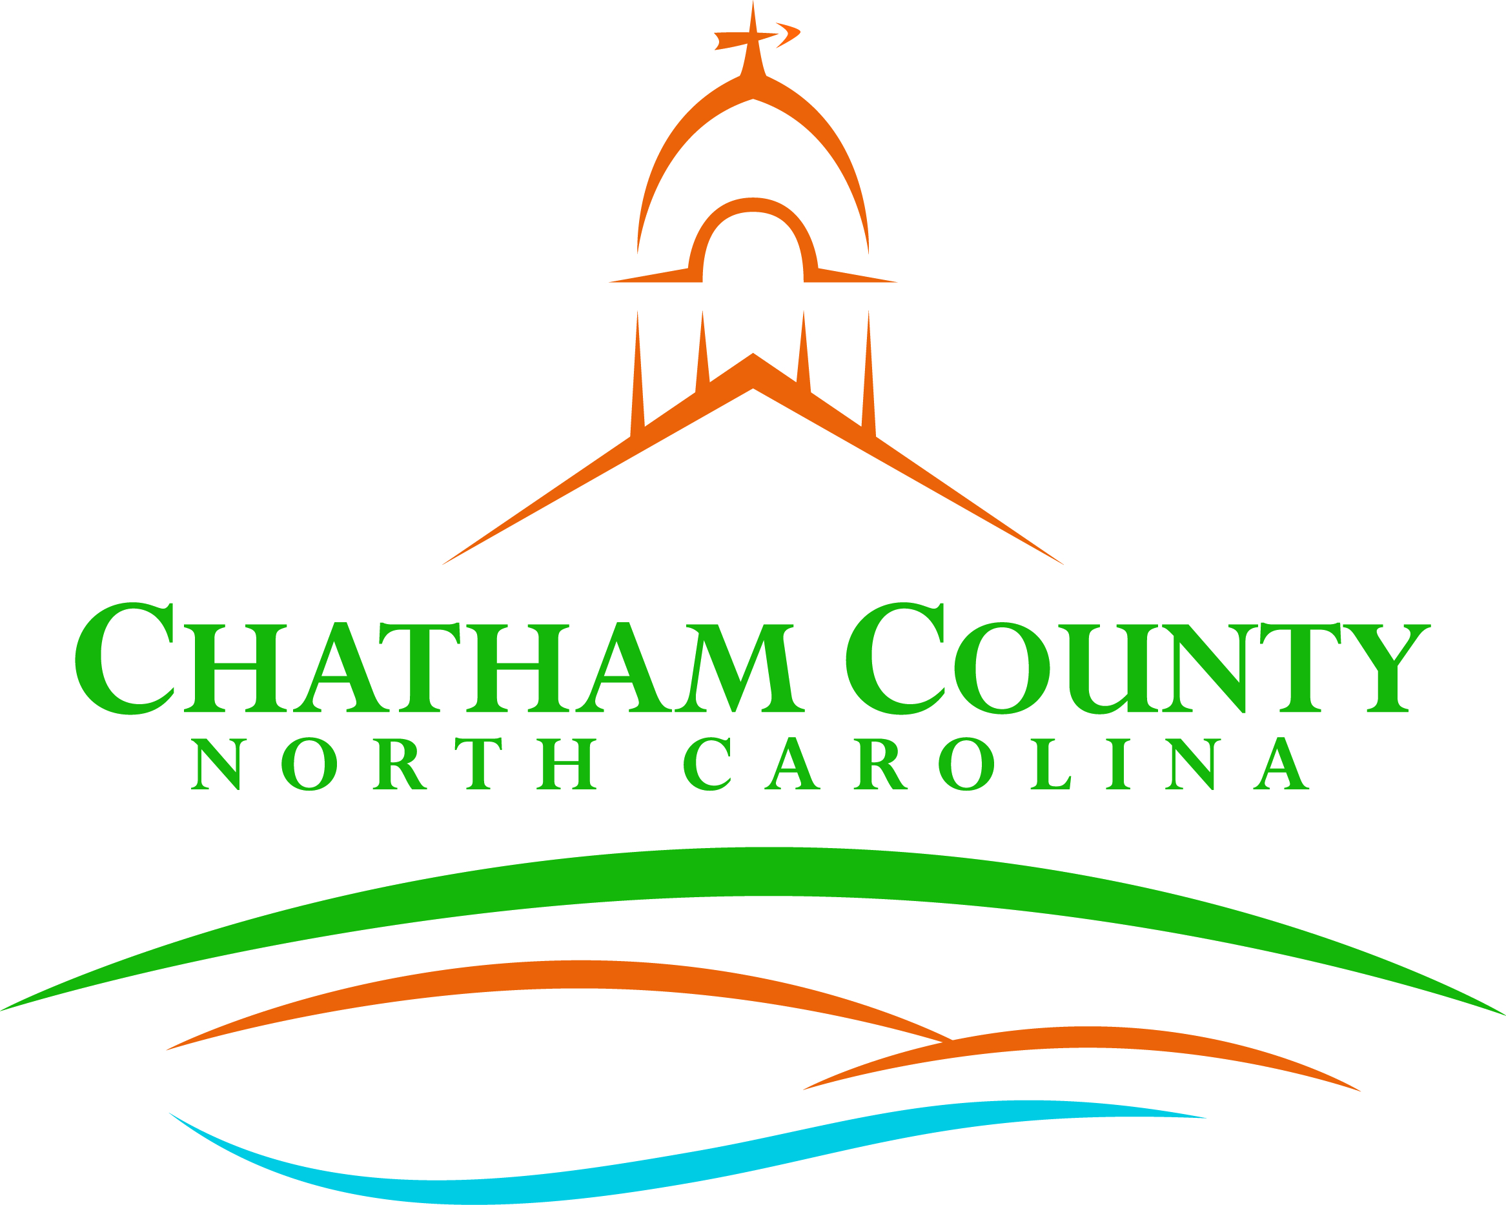
Dan LaMontagne
P. O. Box 1809, Pittsboro, NC 27312-1809 ● Phone: (919) 542-8200
Established 1771
Karen Howard, Chair
Mike Dasher, Vice Chair
Franklin Gomez Flores
David Delaney
Katie Kenlan
CHATHAM COUNTY COMMISSIONERS COUNTY MANAGER

Resolution of the Chatham County Board of Commissioners

ARTS IN EDUCATION WEEK RESOLUTION
Expressing support for the designation of the week of
September 10-16, 2023, as Chatham County Arts in Education Week

Whereas arts education, comprising a rich array of disciplines including dance, media arts, music, theatre, visual arts, and more, is a well-rounded subject and an essential element of a complete education for all students; and

Whereas arts education supports the social and emotional well being of young people in a community by self-awareness, self-efficacy, self-management and perseverance, social awareness and relationship skills are central to any arts education activity, no matter the age and ability of the student or the environment in which the learning takes place; and

Whereas arts education enables students to develop critical thinking and problem-solving skills, imagination and creativity, discipline and collaboration, alternative ways to communicate and express feelings and ideas, and cross-cultural understanding, which supports academic success across the curriculum; and

Whereas arts education contributes to personal growth outside of the classroom including increasing a student’s likelihood to participate in civic life, volunteerism, altruism, and community engagement; and

Whereas arts education contributes to a welcoming school environment where students can express themselves in a safe and positive way; and

Whereas to succeed in today’s economy, students must masterfully develop traits that business leaders demand in a 21st century workforce such as communicating through words, images, sounds, and movement; and

Whereas reduced funding, inequitable access to digital technology, and suspension of arts-based curriculum and programs are leading to reduced access to and participation in arts education for Chatham County students; and

Whereas the arts are an integral part of life in the United States and Chatham County and are an integral part of a complete education which contributes to the vibrancy and vitality of communities and the Nation; and

Be it Resolved, that the Chatham County Board of Commissioners support the designation of September 10-16, 2023, as Arts in Education Week in Chatham County and call on all residents to observe the week with appropriate activities.

Adopted, this the 21st day of August 2023.

Karen Howard, Chair
Chatham County Board of Commissioners
ATTEST:

Lindsay K. Ray, NCMCC, Clerk to the Board
Chatham County Board of Commissioners

