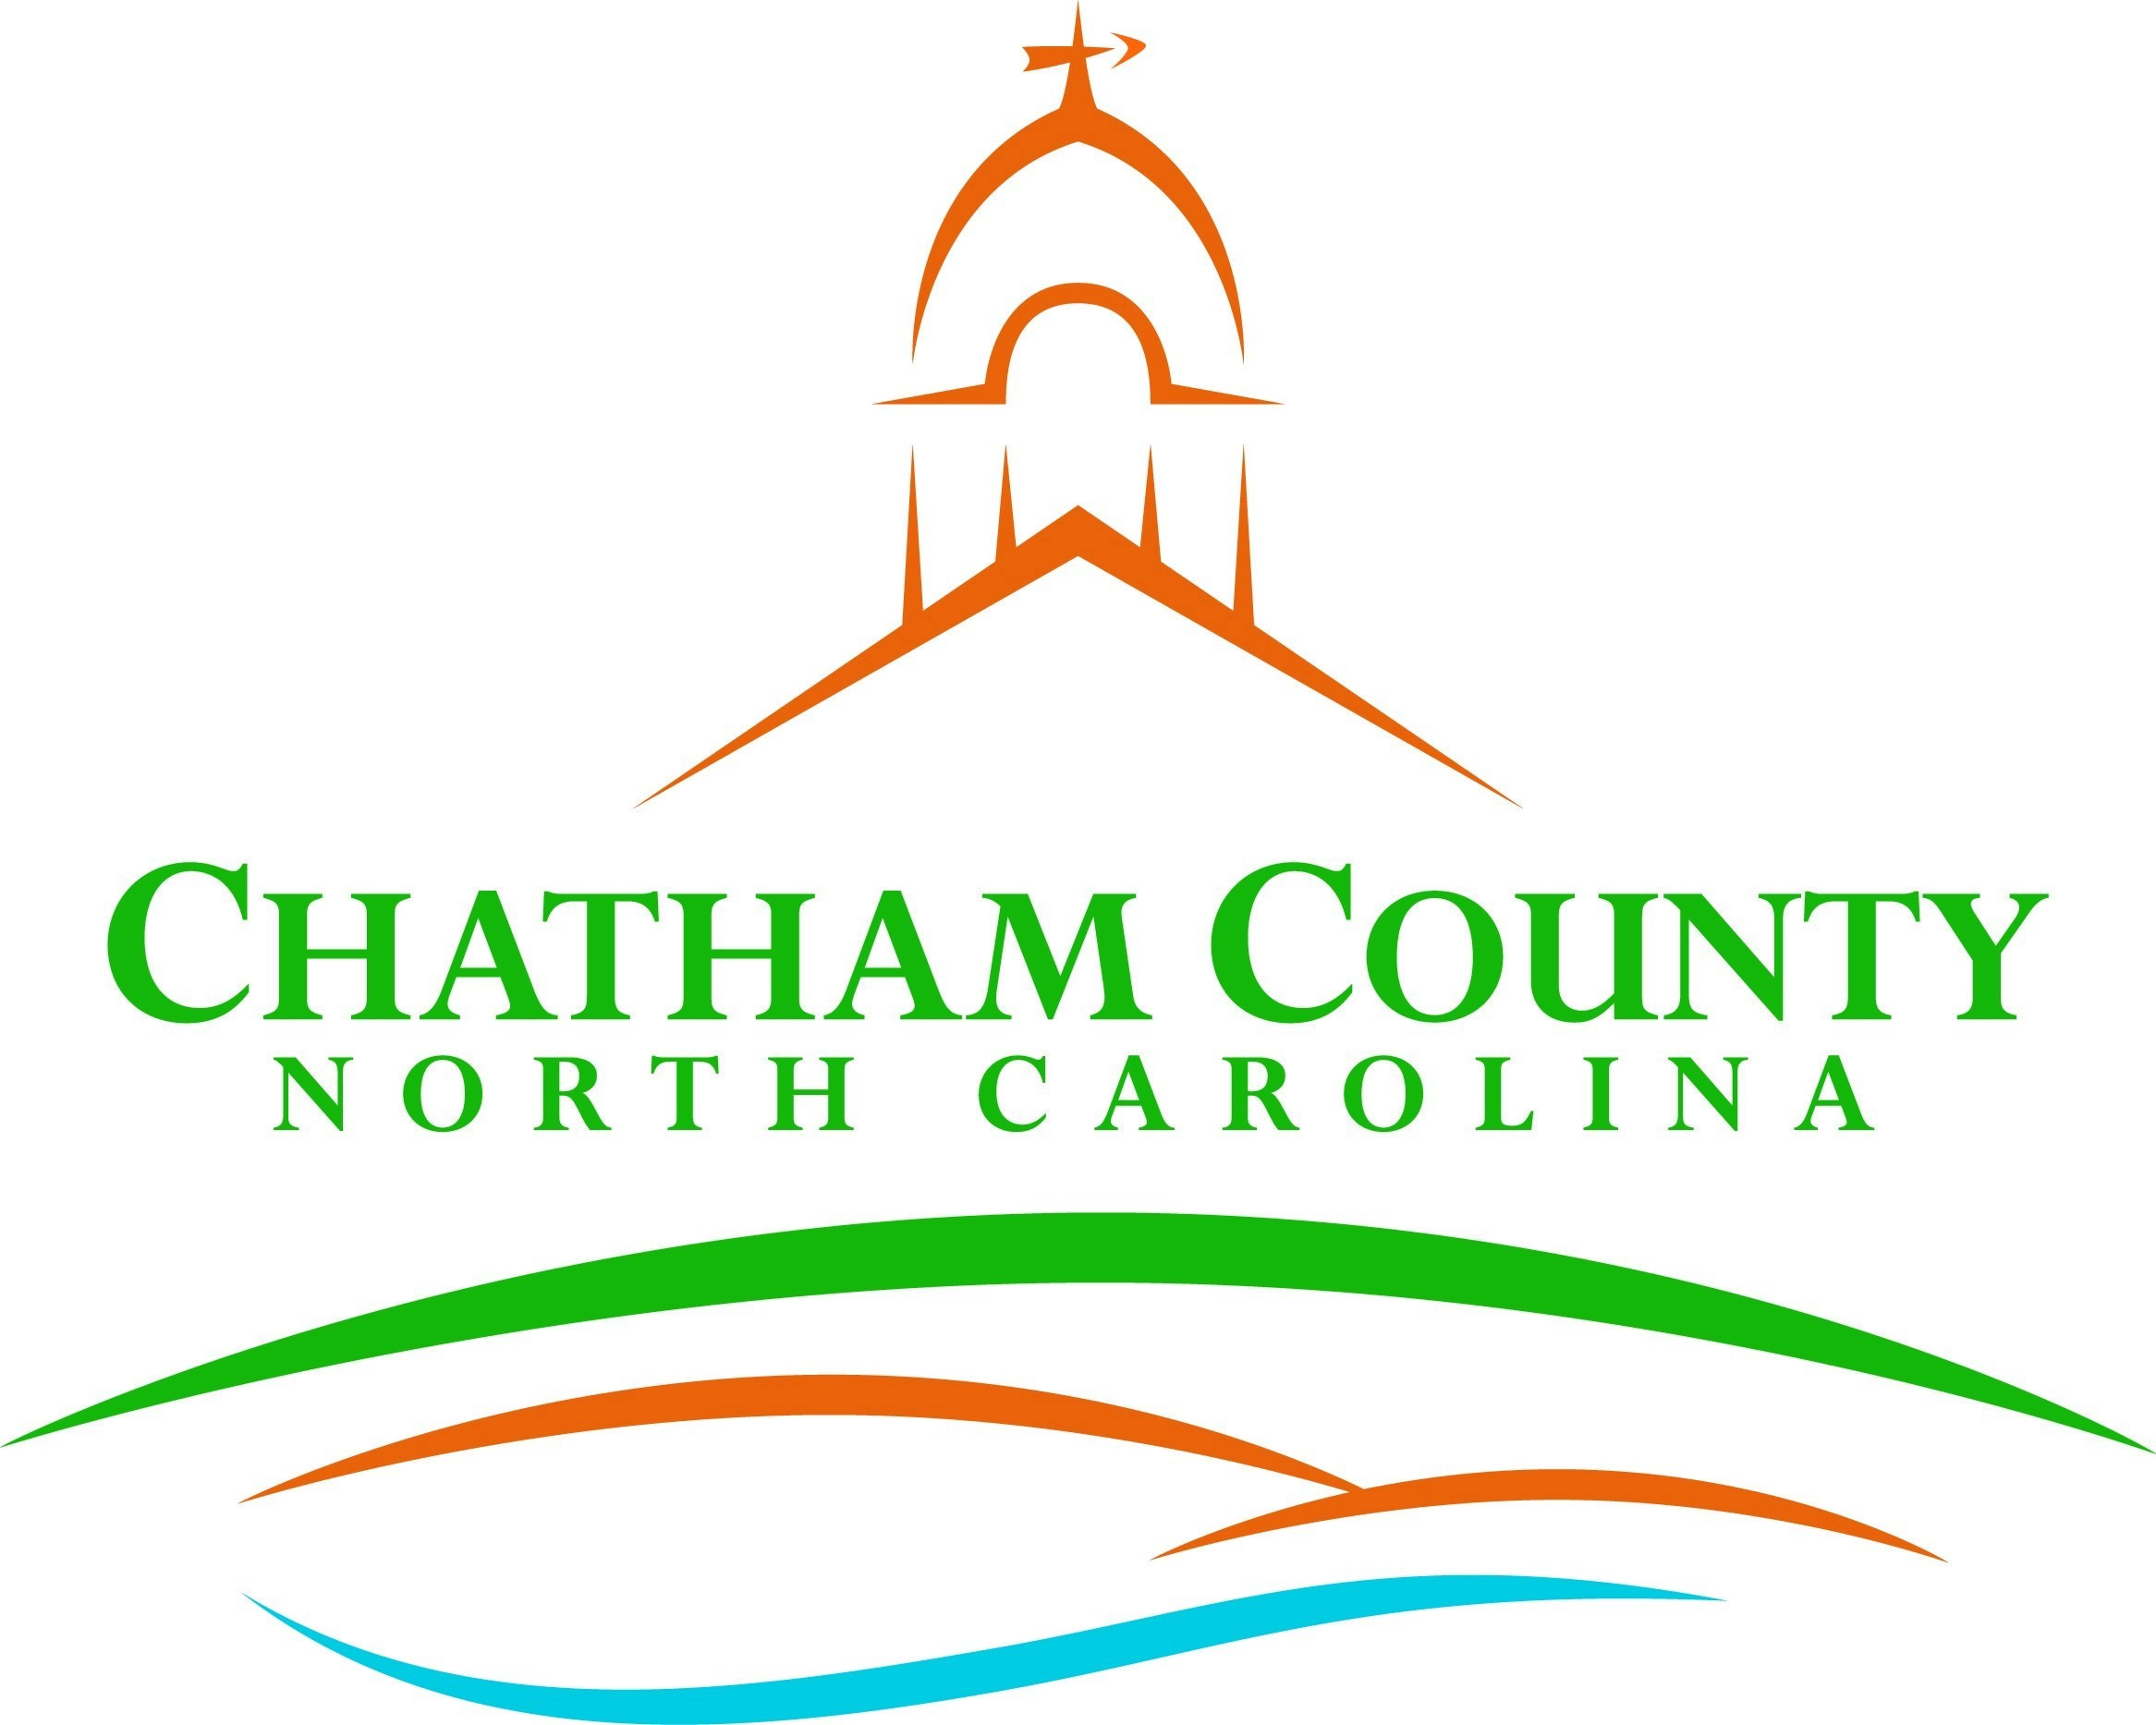
P. O. Box 1809, Pittsboro, NC 27312-1809 ● Phone: (919) 542-8200
Established 1771
Karen Howard, Chair
Mike Dasher, Vice Chair
Franklin Gomez Flores
David Delaney
Katie Kenlan
CHATHAM COUNTY COMMISSIONERS COUNTY MANAGER

Resolution of the Chatham County Board of Commissioners

Authorizing the City of Sanford to Acquire Real Property in Chatham County

Whereas, the City of Sanford (“City”) has entered into an interlocal agreement with the Town of Pittsboro (“Town”) to merge the Town’s utility system for water, reclaimed water, and sewer (“Utility System”) with the City Utility System (the agreement for merger being the “Merger Agreement” and the Town Utility System and City Utility System becoming the “Merged System;”); and
WHEREAS, pursuant to the Merger Agreement, the Town will transfer to the City all real and personal property composing the Town Utility System, including, without limitation, all collection and distribution system infrastructure, all physical infrastructure, real and personal property, and any other items associated with the Town Utility System; and
WHEREAS, the City will need to acquire additional property (whether by easement or fee simple interest), easements, and other types of real or personal property within Chatham; and

WHEREAS, N.C. Gen. Stat. § 153A-15 requires that, before any unit of local government condemns or acquires an interest in property that is located wholly or primarily in a county within which it is not located, it must first have the approval of the county board of commissioners of the county in which the land is located.

NOW, THEREFORE, be it resolved by the Chatham County Board of Commissioners that the City of Sanford is hereby authorized to acquire any interest in land in Chatham County for water, reclaimed water, and sewer utility system purposes by any means available to the City of Sanford, including use of its condemnation authority, if necessary.

Adopted this the 21st day of August 2023.

Karen Howard, Chair
Chatham County Board of Commissioners

ATTEST:

Lindsay K. Ray, NCMCC, Clerk to the Board
Chatham County Board of Commissioners

