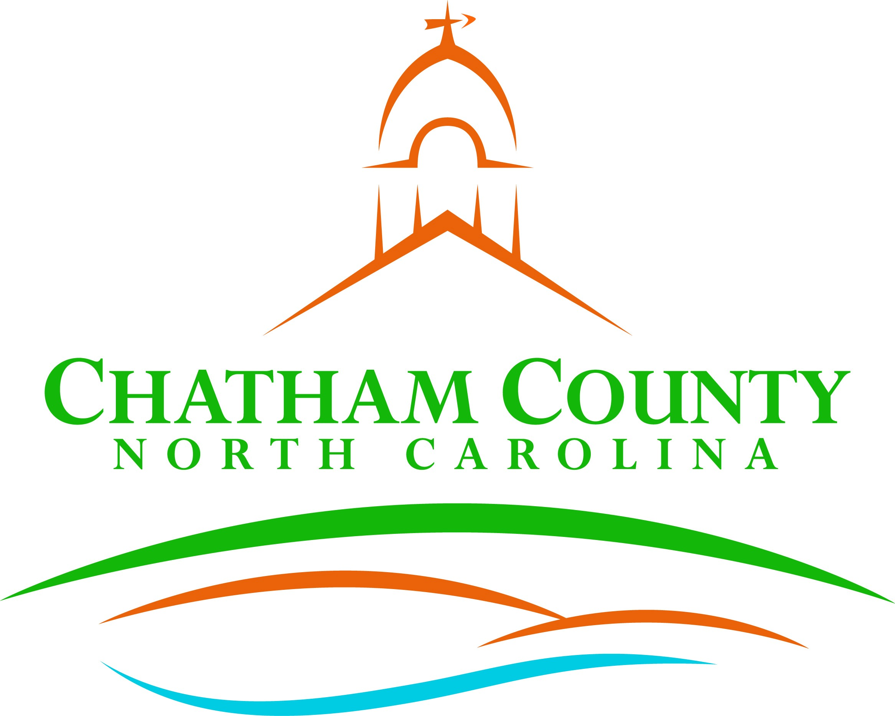
Dan LaMontagne
P. O. Box 1809, Pittsboro, NC 27312-1809 ● Phone: (919) 542-8200
Established 1771
Karen Howard, Chair
Mike Dasher, Vice Chair
Franklin Gomez Flores
David Delaney
Katie Kenlan
CHATHAM COUNTY COMMISSIONERS COUNTY MANAGER

Resolution of the Chatham County Board of Commissioners

Approving an Interlocal Agreement for the Western Intake Partnership Real Estate

WHEREAS, Chatham County, the City of Durham, Town of Pittsboro, and Orange Water and Sewer Authority (“Partner” or “Partners”) have been working cooperatively since 2012 as the Western Intake Partnership (“WIP”) to plan for
the construction of facilities on the western side of Jordan Lake to obtain access to their Jordan Lake allocations; and

WHEREAS, the WIP facilities, built by the Western Intake Partnership, includes, but is not limited to a raw water intake on Jordan Lake, transmission and pumping facilities from the intake to a Regional Water Treatment Facility, the
treatment facilities, and finished water transmission facilities, including storage tanks and pumping stations, connecting to points of delivery with the Pittsboro, Chatham County and Durham water distribution systems (the “WIP Facilities”); and

WHEREAS, the WIP Agreement designates the City of Durham as the Lead Agency, responsible for entering into any contracts on behalf of the WIP; and

WHEREAS, the Partners will need to acquire additional property (whether by easement or fee simple interest) within Chatham County in order to transmit finished water from the Regional Water Treatment Facility to the points of
delivery to the Pittsboro, Chatham County and Durham water distribution systems; and

WHEREAS, N.C. Gen. Stat. § 153A-15 requires that before any unit of local government acquires an interest in property that is located wholly or primarily in a county within which it is not located, it must first have the approval of the county
board of commissioners of the county in which the land is located; and

WHEREAS, N.C. Gen. Stat. § 160A-461 et seq. authorizes units of local government to enter into interlocal agreements with each other to execute any undertaking.

NOW, THEREFORE, be it resolved by the Chatham County Board of Commissioners that the Interlocal Agreement for the Western Intake Partnership Real Estate, which authorizes the City of Durham to acquire any interest in land in Chatham County that is necessary to allow for the construction and operation of the water infrastructure contemplated for the Western Intake Partnership Facilities, by any means available to the City of Durham, including use of its condemnation authority, if necessary, is hereby approved.

Adopted this the 7th day of August 2023.

Karen Howard, Chair
Chatham County Board of Commissioners

ATTEST:

Lindsay K. Ray, NCMCC, Clerk to the Board
Chatham County Board of Commissioners

