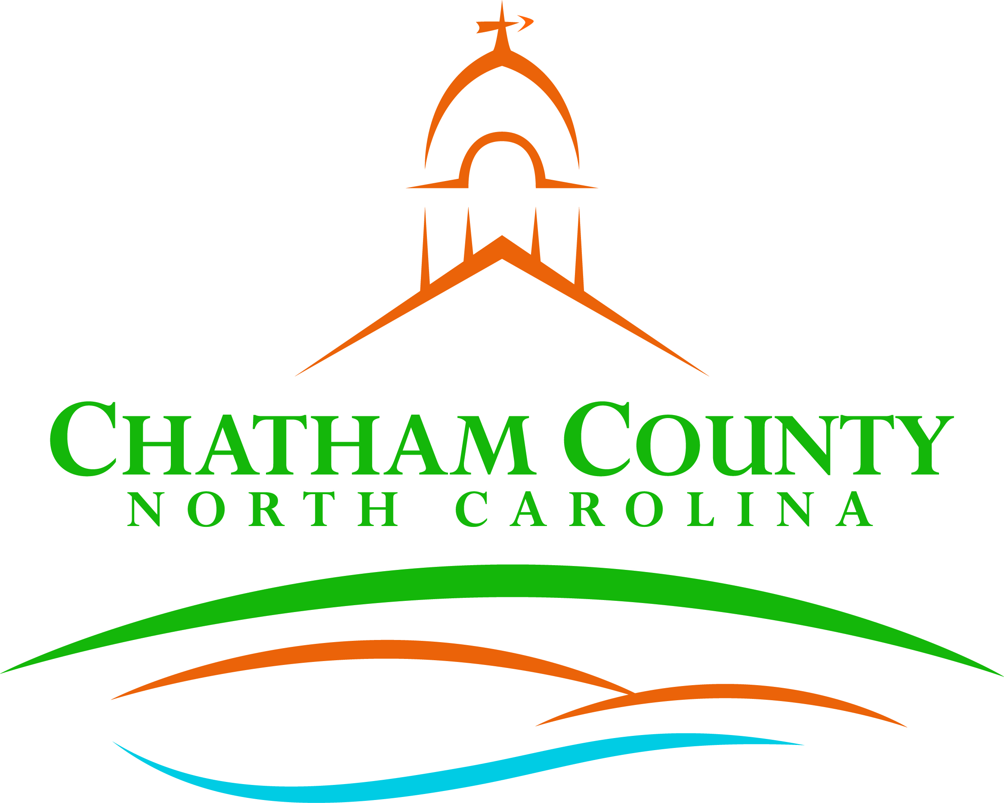
Dan LaMontagne
P. O. Box 1809, Pittsboro, NC 27312-1809 ● Phone: (919) 542-8200
Established 1771
Karen Howard, Chair
Mike Dasher, Vice Chair
Franklin Gomez Flores
David Delaney
Katie Kenlan
CHATHAM COUNTY COMMISSIONERS COUNTY MANAGER

Resolution of the Chatham County Board of Commissioners

RESOLUTION APPROVING THE TAX COLLECTOR’S ANNUAL SETTLEMENT

WHEREAS, Chatham County Tax Administrator has provided in his annual settlement preliminary reports containing the list of the names of persons owning real property whose taxes remain unpaid; and

WHEREAS, North Carolina General Statute 105-373(a)(2) states that the governing body of the taxing unit shall enter upon its minutes the names of persons owing taxes but listed no real property whose taxes remain unpaid and whom it finds to be insolvent; and

WHEREAS, a diligent effort has been made to collect these taxes out of the perianal property of the taxpayers concerned; and

WHEREAS, other means open to the collector have been used for collection of such taxes; and

WHEREAS, where applicable, collection outside the taxing unit has been attempted; and

WHEREAS, all information has been provided concerning those taxpayers as may be of interest to or required by the governing body; and

WHEREAS, the allowance of insolvents does not extinguish the claim for taxes; and

WHEREAS, the collector will continue to pursue collections of such taxes until the ten-year statute of limitations expires; and

WHEREAS, the Board of Commissioners by resolution should accept the lists as presented and declares that no one on the preliminary report of persons owing taxes but listed no real property should be determined insolvent; and

NOW THEREFORE, BE IT RESOLVED, that the list of persons owing taxes but listed no real property whose taxes remain unpaid along with the list of unpaid 2022 real property taxes be charged to the Tax Administrator for collections as delinquent taxes.

Adopted, this the ____day of ____________________.

Karen Howard, Chair
Chatham County Board of Commissioners
ATTEST:

Lindsay K. Ray, NCMCC, Clerk to the Board
Chatham County Board of Commissioners

