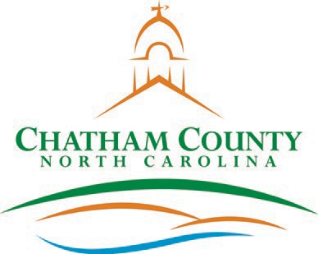**CHATHAM COUNTY COMMISSIONERS COUNTY MANAGER**

Karen Howard, Chair

Mike Dasher, Vice Chair

Franklin Gomez Flores

Katie Kenlan

David Delaney

Dan LaMontagne

Established 1771

P. O. Box 1809, Pittsboro, NC 27312-1809 ● Phone: (919) 542-8200

**Resolution of the Chatham County Board of Commissioners**

Declaring Property Surplus and Conveying Property

**WHEREAS,** the Chatham County Health Department has the following items to be declared surplus as they are no longer needed by the Department; and

* Two gas ranges

**WHEREAS,** NC General Statutes 160A-279 authorizes the Board to approve the conveyance of personal property to a non-profit agency with or without consideration; and

**NOW, THEREFORE, BE IT RESOLVED** by the Board of Commissioners of the County of Chatham:

**Section 1:** The Board declares the above listed items to be surplus property; and

**Section 2:** That the Board approves the conveyance of the identified property to Alliance Serving Chatham County (ACSS) to use the supplies provided by the Health Department exclusively for cooking meals with healthier foods for community members experiencing food insecurity.

Adopted, this the day of , 2023.

Karen Howard, Chair

Chatham County Board of Commissioners

ATTEST:

_____________________________________

Lindsay K. Ray, NCCCC, Clerk to the Board Chatham County Board of Commissioners