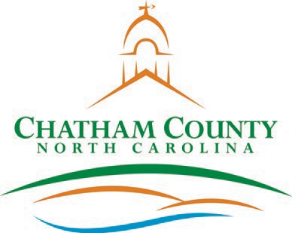**CHATHAM COUNTY COMMISSIONERS COUNTY MANAGER**

Karen Howard, Chair

Franklin Gomez Flores, Vice Chair

Diana Hales

Mike Dasher

Robert Logan

Dan LaMontagne

Established 1771

P. O. Box 1809, Pittsboro, NC 27312-1809 ● Phone: (919) 542-8200

**Resolution of the Chatham County Board of Commissioners**

**Approving an Interlocal Agreement with the Town of Pittsboro to allow**

**the Town to have an account on the County’s OpenGov Software License**

**WHEREAS**, the North Carolina General Assembly has approved N.C. Gen. Stat. § 160A-460, *et seq*. for the joint exercise by two or more units of local government, or the contractual exercise by one unit for one or more other units, of any power, function, public enterprise, right, privilege, or immunity of local government, and

**WHEREAS** the County and Town of Pittsboro desire to facilitate the application for and payment of Town permit fees by allowing Town residents to access an account on the County’s OpenGov Software License; and

**WHEREAS**, the County and Town have agreed to memorialize this software access through an Interlocal agreement;

**NOW THEREFORE BE IT RESOLVED,** the Chatham County Board of Commissioners gives its full support of this Interlocal Agreement.

Adopted this the 19th day of September 2022.

Karen Howard, Chair

Chatham County Board of Commissioners

ATTEST:

_____________________________________

Lindsay K. Ray, NCMCC, Clerk to the Board Chatham County Board of Commissioners