Attn: Chatham County Appearance Commission

\*No landscaping or signage is planned to be added or changed for this project. This is my residence.

3721 Old Graham Road

Site map, current photos (8/4/2022), and residence floor plan.

Trees surround the entire property on all four sides.

Facing the road/ front yard (East)

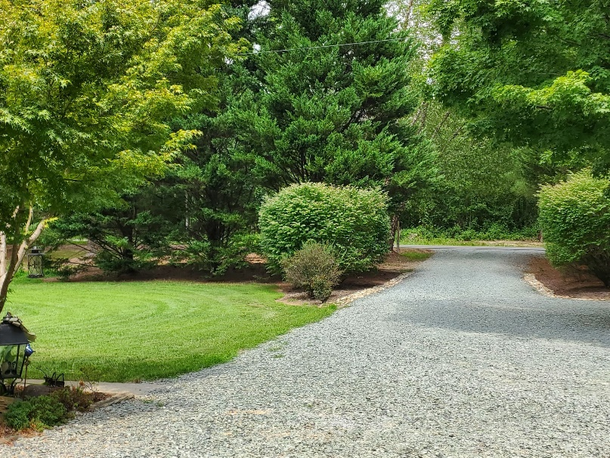

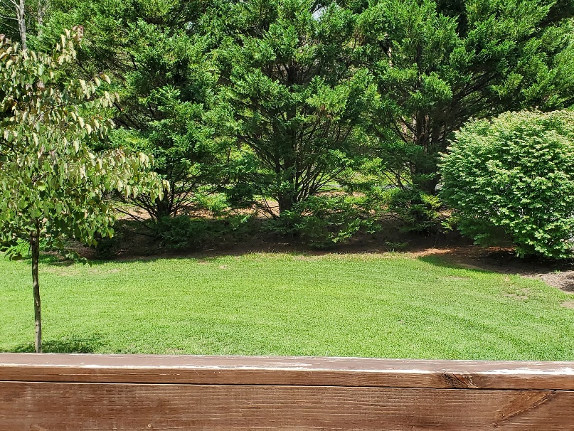

Facing the West neigbor (back yard)

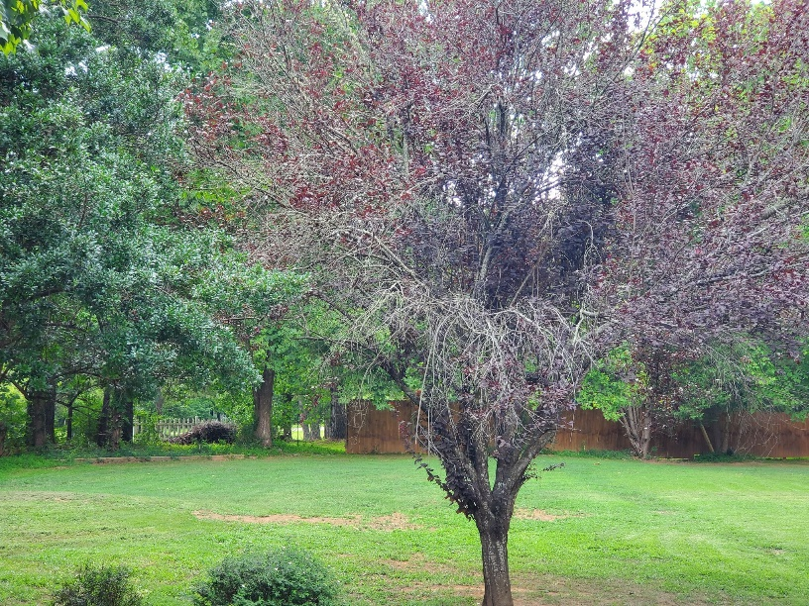

Facing the South neighbor

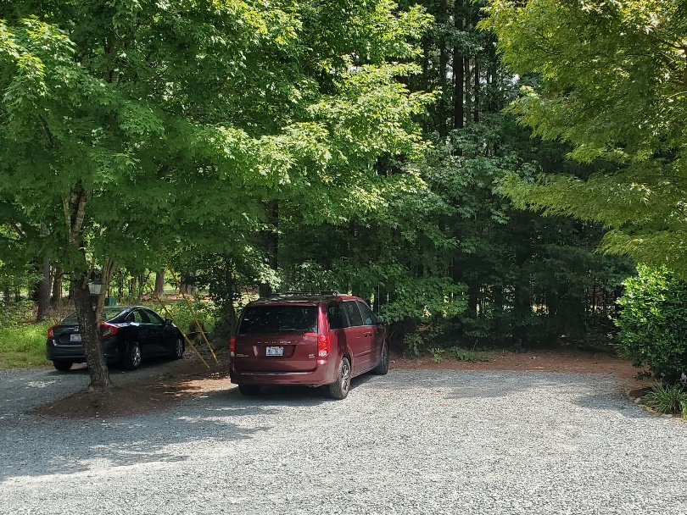

Facing the North neigbor (playground area shown)

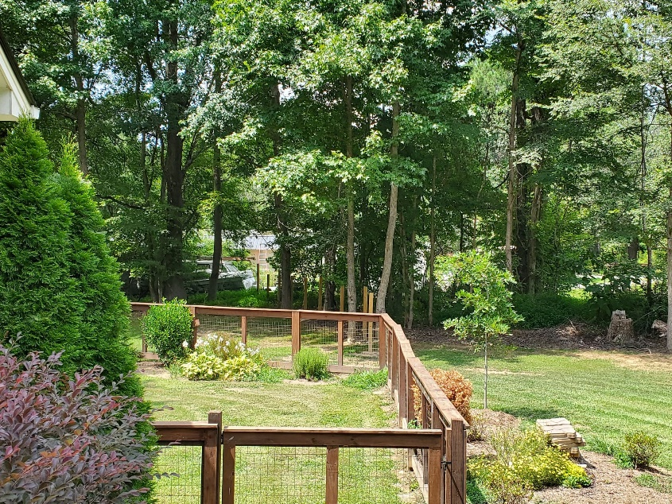

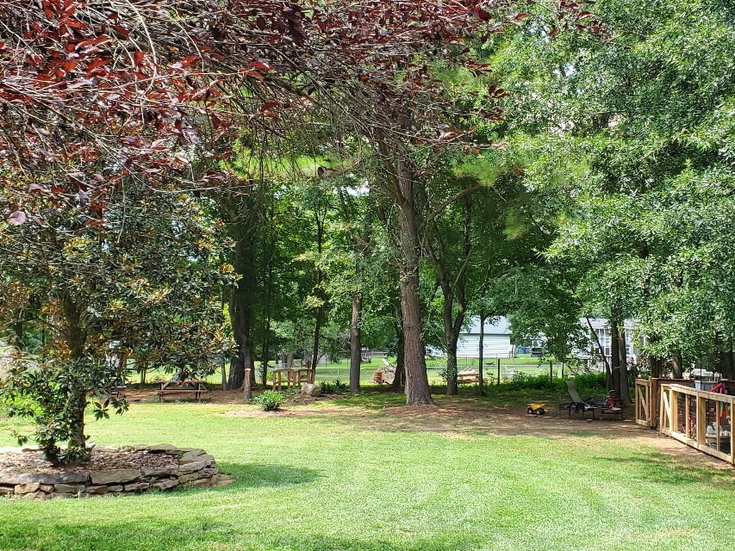

Whole property site map

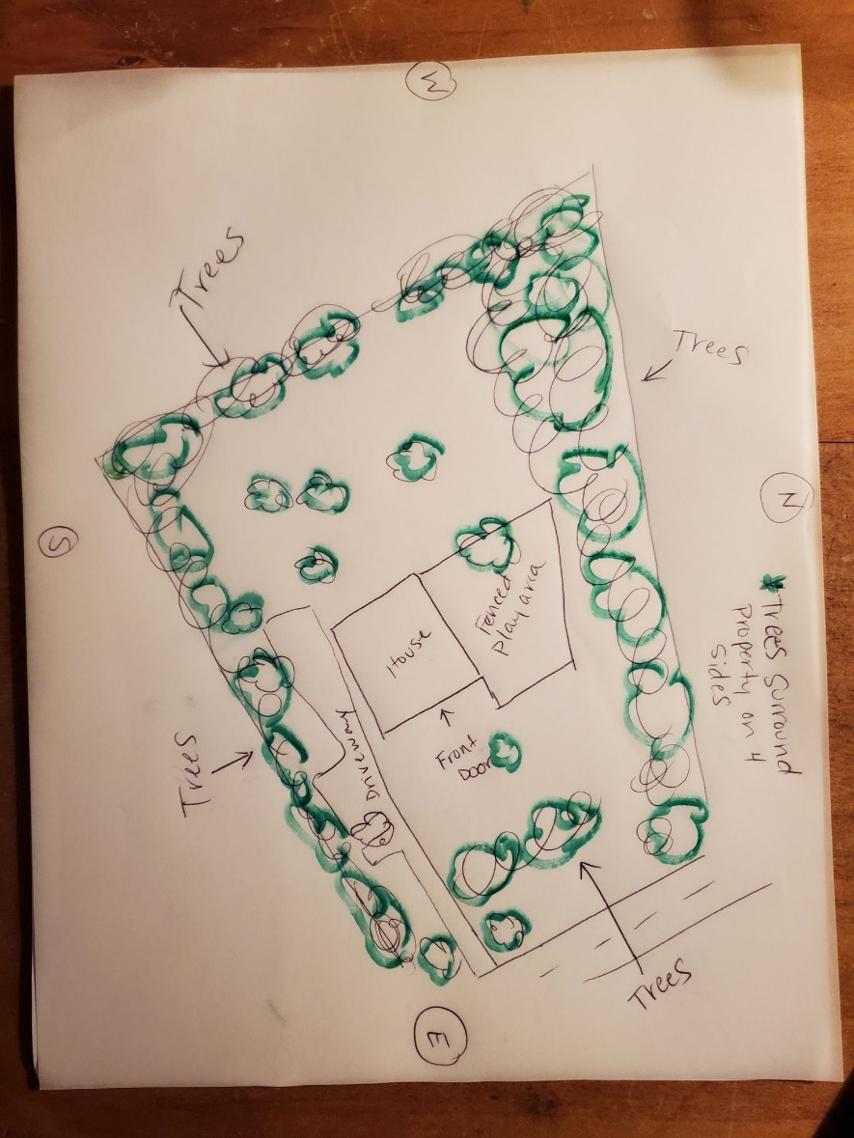

Floor plan (purple area used for childcare)

