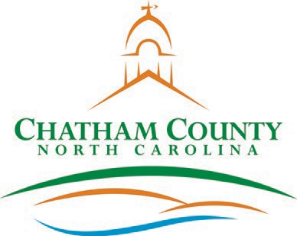**CHATHAM COUNTY COMMISSIONERS COUNTY MANAGER**

Mike Dasher, Chair Diana Hales, Vice Chair Jim Crawford

Karen Howard Franklin Gomez Flores

Dan LaMontagne

Established 1771

P. O. Box 1809, Pittsboro, NC 27312-1809 ● Phone: (919) 542-8200

**Resolution of the Chatham County Board of Commissioners**

Declaring Property Surplus and Conveying Property

**WHEREAS,** the Chatham County Health Department has two bicycle trailers to be declared surplus as they are no longer needed by the Department; and

**WHEREAS,** NC General Statutes 160A-279 authorizes the Board to approve the conveyance of personal property to a non-profit agency with or without consideration; and

**NOW, THEREFORE, BE IT RESOLVED** by the Board of Commissioners of the County of Chatham:

**Section 1:** The Board declares the above listed items to be surplus property; and

**Section 2:** That the Board approves the conveyance of the identified property to Saint Bartholomew’s Episcopal Church for promoting healthy exercise habits.

Adopted, this the day of , 2021.

Mike Dasher, Chair

Chatham County Board of Commissioners

ATTEST:

_____________________________________

Lindsay K. Ray, NCCCC, Clerk to the Board Chatham County Board of Commissioners