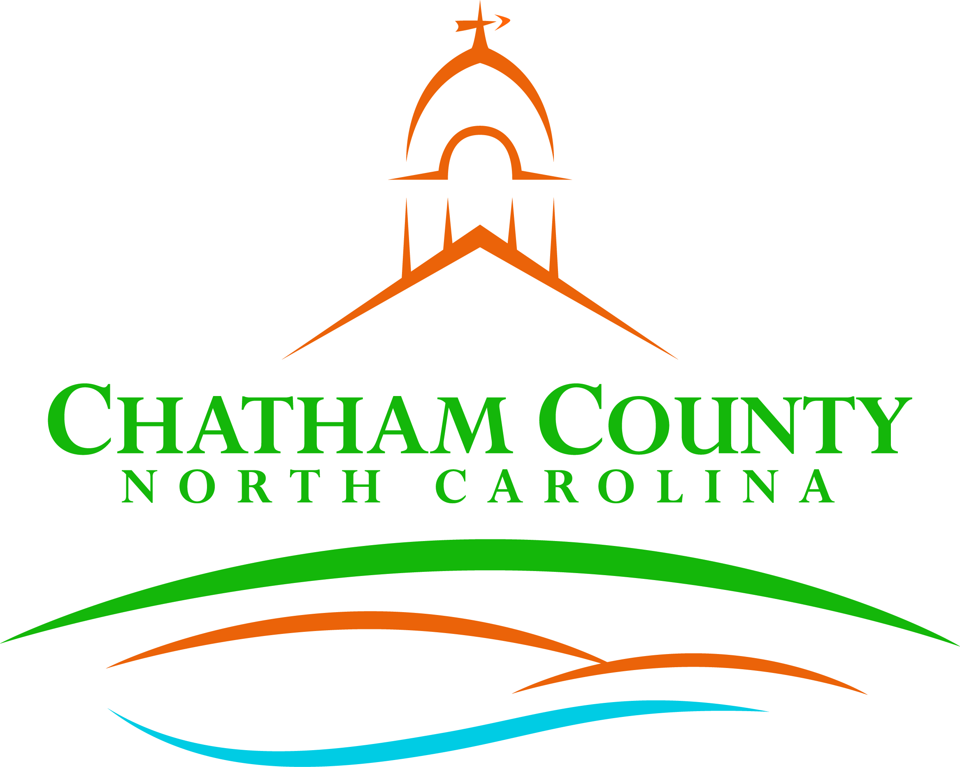
Dan LaMontagne
P. O. Box 1809, Pittsboro, NC 27312-1809 ● Phone: (919) 542-8200
Established 1771
Mike Dasher, Chair
Diana Hales, Vice Chair
Jim Crawford
Franklin Gomez Flores
Karen Howard
CHATHAM COUNTY COMMISSIONERS COUNTY MANAGER

Resolution of the Chatham County Board of Commissioners

RECOGNIZING AND COMMEMORATING THE 76TH ANNIVERSARY OF NATIONAL DISABILITY EMPLOYMENT AWARENESS MONTH

WHEREAS, October 2021 marks the 76th anniversary of National Disability Employment Awareness Month; and

WHEREAS, The purpose of National Disability Employment Awareness Month is to educate about disability employment issues and celebrate the many and varied contributions of America's workers with disabilities; and

WHEREAS, The history of National Disability Employment Awareness Month traces back to 1945 when Congress enacted a law declaring the first week in October each year "National Employ the Physically Handicapped Week;" and

WHEREAS, In 1962, the word "physically" was removed to acknowledge the employment needs and contributions of individuals with all types of disabilities; and

WHEREAS, In 1988, Congress expanded the week to a month and changed the name to National Disability Employment Awareness Month; and

WHEREAS, Workplaces welcoming of the talents of all people, including people with disabilities, are a critical part of our efforts to build an inclusive community and strong economy; and

WHEREAS, Activities during this month will reinforce the value and talent people with disabilities add to our workplaces and communities and affirm Chatham County’s commitment to an inclusive community that increases access and opportunities to all, including individuals with disabilities.

NOW, THEREFORE, BE IT RESOLVED, That the Chatham County Board of Commissioners recognize and commemorate the 76th anniversary of National Disability Employment Awareness Month; and be it further

RESOLVED, That the Chatham County Board of Commissioners call upon employers, schools, and other community organizations in Chatham County to observe October with appropriate programs and activities, and to advance its important message that people with disabilities add value and talent to our workplaces and communities; and be it further

RESOLVED, That the Chatham County Board of Commissioners call upon employers, schools, and other community organizations in Chatham County to pledge to continue to take steps throughout the year to recruit, hire, retain, and advance individuals with disabilities and work to pursue the goals of opportunity, full participation, economic self-sufficiency, and independent living for people with disabilities.
Adopted this, the 20th Day of September, 2021.

Adopted, this the ____day of ____________________.

Mike Dasher, Chair
Chatham County Board of Commissioners
ATTEST:

Lindsay K. Ray, NCCCC, Clerk to the Board
Chatham County Board of Commissioners

