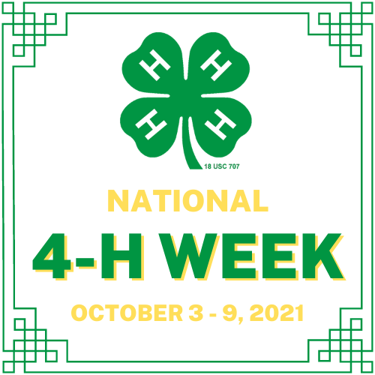

**NATIONAL 4-H WEEK PROCLAMATION**

**WHEREAS**, 4-H youth across the nation are leading efforts to solve problems in their communities and make a difference for their futures; and

**WHEREAS**, 4-H is the largest youth development organization in North Carolina and the largest in the nation with over six million participants; and

**WHEREAS**, 4-H in North Carolina claims 260,000 youth members and 13,000 volunteers, while Chatham County’s 4-H program numbers more than 85members and more than 25 volunteers; and

**WHEREAS**, 4-H as part of the NC Cooperative Extension System of NC State University and NCA&T State University is a program where youth learn through opportunities that provide them hands-on experiences in 4-H’s mission mandates of science, engineering and technology; healthy living; and citizenship; and

**WHEREAS**, 4-H has connected youth and their communities with the innovative research and resources from our nation’s 112 land-grant universities and colleges for more than 118 years.

**NOW, THEREFORE,** theChatham County Board of Commissioners, do hereby proclaim October 3-9, 2021, as National 4-H Week in Chatham County. We urge the people of this County to take advantage of the opportunity to become more aware of this special program that enhances our young people’s interests in their futures as part of Chatham County 4-H Youth Development and to join us in recognizing the unique partnership between our County and our State University System.

Adopted this the ____ day of ______ 2021.

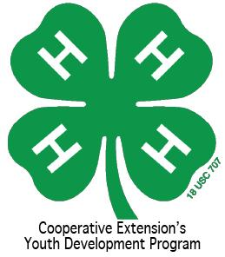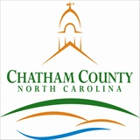

____________________________________

***_______________***, Chairman

Chatham County Board of Commissioners

