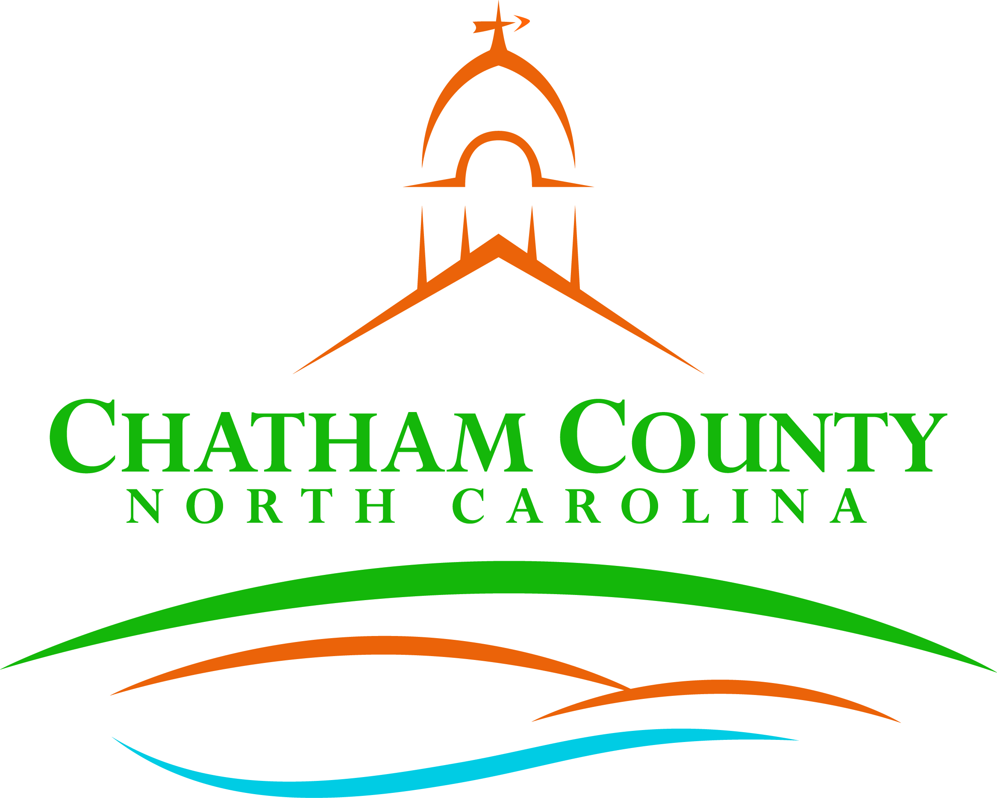
Dan LaMontagne
P. O. Box 1809, Pittsboro, NC 27312-1809 ● Phone: (919) 542-8200
Established 1771
Mike Dasher, Chair
Diana Hales, Vice Chair
Jim Crawford
Franklin Gomez Flores
Karen Howard
CHATHAM COUNTY COMMISSIONERS COUNTY MANAGER

Resolution of the Chatham County Board of Commissioners

Resolution to Improve Student Learning Conditions

WHEREAS, Chatham County is committed to strong public schools that ensure safe, nurturing, and academically rigorous learning environments,

WHEREAS, educators and school workers are the most valuable resource we have in supporting the social, emotional, and academic growth of our students, and

WHEREAS, education support personnel are the only state employees in NC without a minimum base wage of at least $15/hour; and

WHEREAS, students and families throughout the state continue to navigate the psychological and academic stress and trauma associated with the COVID-19 pandemic, and our schools need additional human resources to provide adequate mental health and academic support, and

WHEREAS, public dollars should be invested in schools that are accountable, publicly managed, and provide a free public benefit to all NC citizens and residents, not diverted through vouchers into private institutions that are exempt from the NC Constitutional requirements to provide a sound, basic public education to each student, and

WHEREAS, North Carolina’s investment in our students and schools has dropped from 52.5% of our state budget in 1970 to just 39% of the state budget in the 2017-18 school year, and

WHEREAS, the NC General Assembly has increasingly shifted the burden of Public School funding to local County Governments, which in 2015 appropriated 24% of all funding for NC public schools, compared to 21.5% in 1998; and

WHEREAS, North Carolina invested $2,866 less in each of our students than the national average for the 2019-20 school year, and an investment consistent with the national average would provide an additional $24,438,382.00 to better support the 8527 students enrolled in Chatham County Schools, allowing us to offer additional resources, reduce class size, and better compensate school workers, and

WHEREAS, NC school districts have more than $8 billion in unmet capital improvement needs, including $76,355,043.00 in Chatham County Schools, and

WHEREAS, Local governments fund 97% of school repair and construction in North Carolina, as the General Assembly has not approved a state bond for K-12 capital needs since 1996, and substantially reduced lottery funding for the NC Public School Building Capital Fund in, and

WHEREAS, revenue for K-12 school funding can be raised more efficiently and equitably at the statewide level by the General Assembly than by individual counties, yet many rural and lower wealth counties have had to raise local tax rates to support students and school workers,

NC Public School Forum 2020 Local School Finance Study (Page 8)
North Carolina Center For County Research (see page 3); NC Association of County Commissioners.
National Education Association Rankings of the States 2019 and Estimates of School Statistics 2020. (Page 57).
NC Department of Public Instruction: 2015-16 Facilities Needs Assessment.
North Carolina Center For County Research (see page 2); NC Association of County Commissioners.

THEREFORE BE IT RESOLVED THAT:
Chatham County Public Schools urges each legislator representing Chatham County, and each legislator in the North Carolina General Assembly, to co-sponsor and vote for legislation that:
- Increases North Carolina’s per-student spending in order to more equitably support student learning throughout our state, including in rural and less wealthy districts, by enacting the reforms listed below, and
- Expands funding for districts to hire more school nurses, counselors, social workers, psychologists, and instructional assistants, to support the academic, social, and emotional well-being of students, and
- Provides education support professionals with a living wage by guaranteeing a $15 minimum base pay for all NC school workers, and adjusts the relevant pay scale accordingly to avoid wage compression, and
- Reforms the salary scale to provide a 5% salary increase and subsequent cost of living adjustments for active and retired educators, and to restore longevity and masters pay to improve educator recruitment and retention of experienced educators, and
- Approves a statewide K-12 school construction and renovation bond that provides Local Education Agencies with much needed funds, and
- Restores state health care benefits for school workers who retire after a lifetime of service to our students, including individuals hired during and after January of 2021, and
- Reduces barriers to student learning by expanding funding for broadband, high speed internet access in North Carolina, with an emphasis on rural, lower-wealth, and communities of color that lack access, and
- Freezes funding for the NC private school voucher program at current levels until the policy objectives named above have been achieved, and requires any private school accepting vouchers to meet the same academic, financial, and transparency standards as are other institutions receiving public funds.

Adopted, this the ____day of ____________________.

Mike Dasher, Chair
Chatham County Board of Commissioners
ATTEST:

Lindsay K. Ray, NCCCC, Clerk to the Board
Chatham County Board of Commissioners

