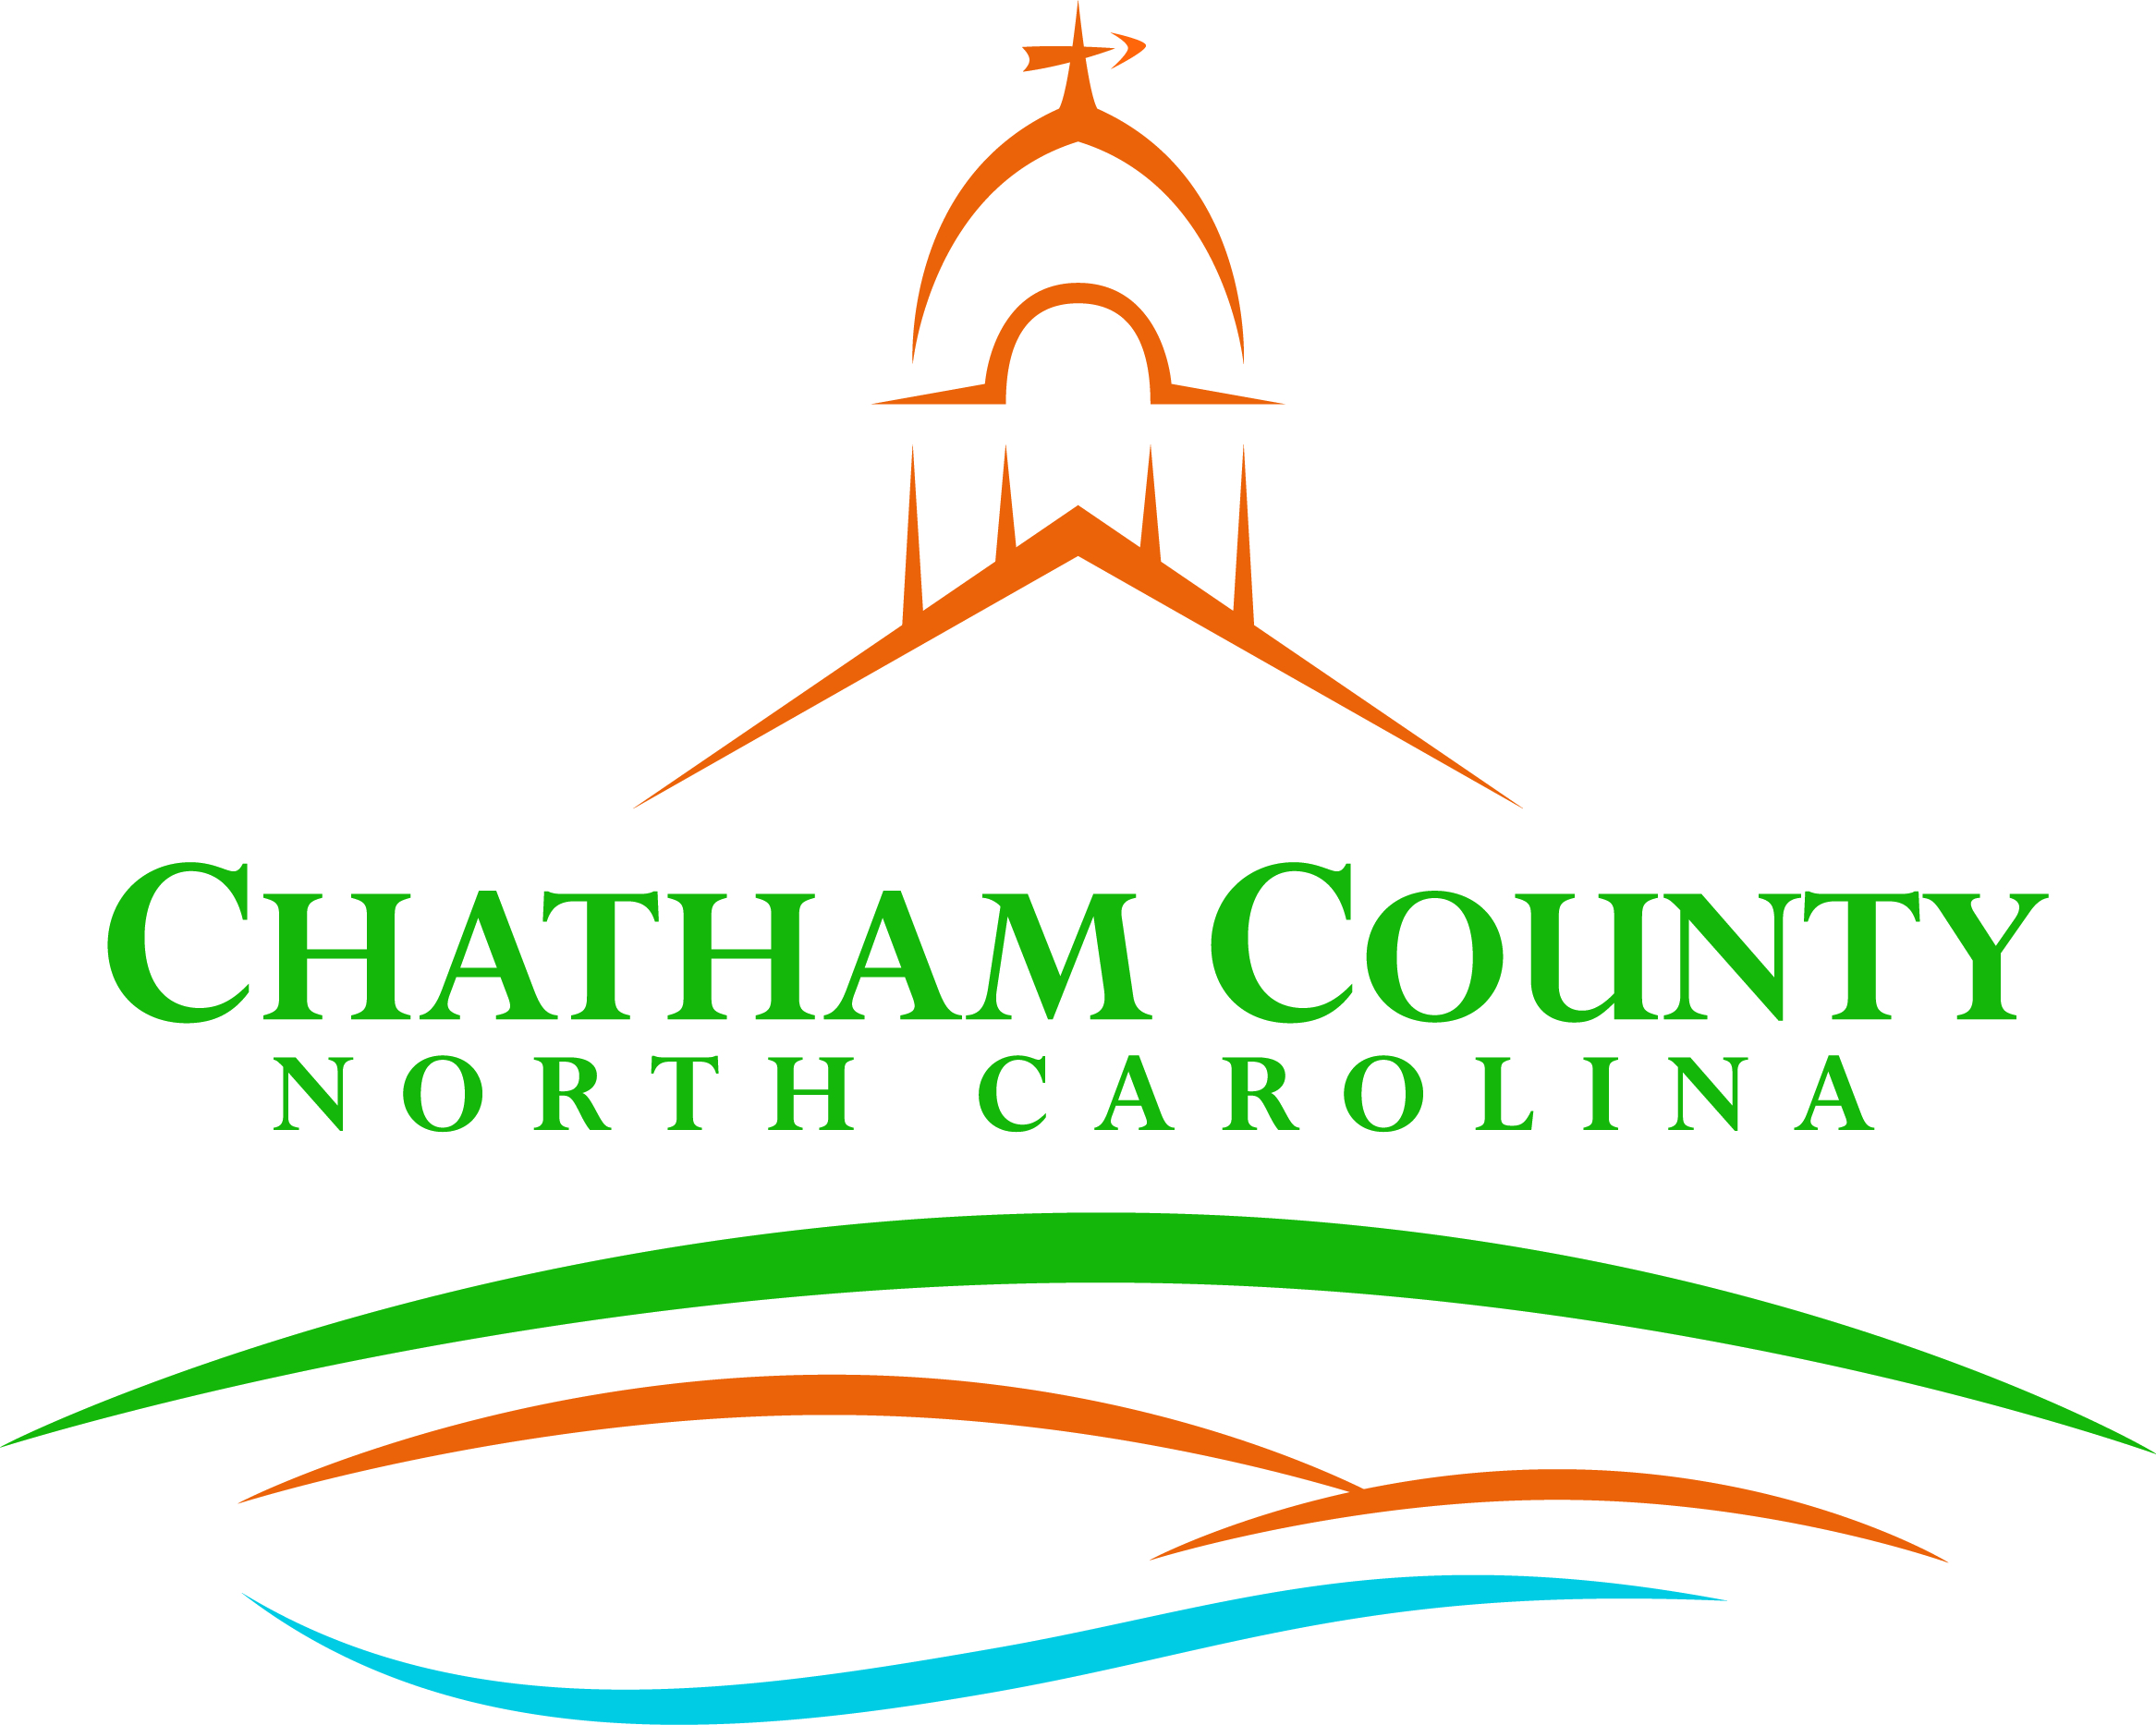
Dan LaMontagne
P. O. Box 1809, Pittsboro, NC 27312-1809 ● Phone: (919) 542-8200
Established 1771
Mike Dasher, Chair
Diana Hales, Vice Chair
Jim Crawford
Franklin Gomez Flores
Karen Howard
CHATHAM COUNTY COMMISSIONERS COUNTY MANAGER

Resolution of the Chatham County Board of Commissioners

Chatham County Cattle Celebration

2021 is a landmark year for cattle as we celebrate the 500th anniversary of the arrival of cattle in North America. Our recorded history places cattle on our continent as early as 1521 when the appointed viceroy of New Spain, Gregorio de Villalobos, decided to take his chances and go against a Spanish law prohibiting cattle trading in Mexico. He acquired six Spanish cows and a bull from what we know today as the Dominican Republic and brought them to Veracruz, Mexico. The opportunity and its potential for growth and profit were too good to pass up. This was truly the beginning of cattle cultivation in North America.

Since then, cattle have become an integral part of American agriculture – especially in Chatham County, NC. Our county’s cattle production, which ranks third in NC’s total cattle population, are a major part of Chatham’s community and local economy. Around 34,000 head of cattle reside on our pastures resulting in one cow per 2-3 people. In addition to sheer numbers, our ranchers produce high-quality cattle among a diversity of breeds including Brown Swiss, Pineywoods, Texas Longhorn, Belted Galloway, Hereford, Angus, Guernsey, South Poll, and Holstein to mention a few, helping preserve a diversity of genetics for our future farmers and land managers. Cattle can be raised as an environmentally friendly tool for maintaining our pastoral, rural landscapes, while also yielding a local source of nourishing protein. Chatham cattle farmers pride themselves in producing both high quality products that focus on animal welfare and land management.

With several century farmers in our county, many farmers are multi-generational and have learned the trade from their parents who learned from their parents. This deep history and appreciation for livestock creates an unmatched passion for the industry that is represented in the products they sell and the farms they operate. Chatham’s cattle farms may not all look the same or use the same practices, but they share the common goal of promoting agriculture, producing food to feed our families, and seeing their way of life pass on to future generations. Public surveys in Chatham County have made evident that preserving rural character is the most important goal among surveyed citizens. Our continuous support of local farms is more important now than ever. Support our farmers by buying local: Chatham County Buy Local Guide.

We want to celebrate Chatham County and its long history with cattle and hope to bring greater public attention to the amazing beef and dairy products to be had in our own backyard.

Adopted, this the ____day of ____________________.

Mike Dasher, Chair
Chatham County Board of Commissioners
ATTEST:

Lindsay K. Ray, NCCCC, Clerk to the Board
Chatham County Board of Commissioners

