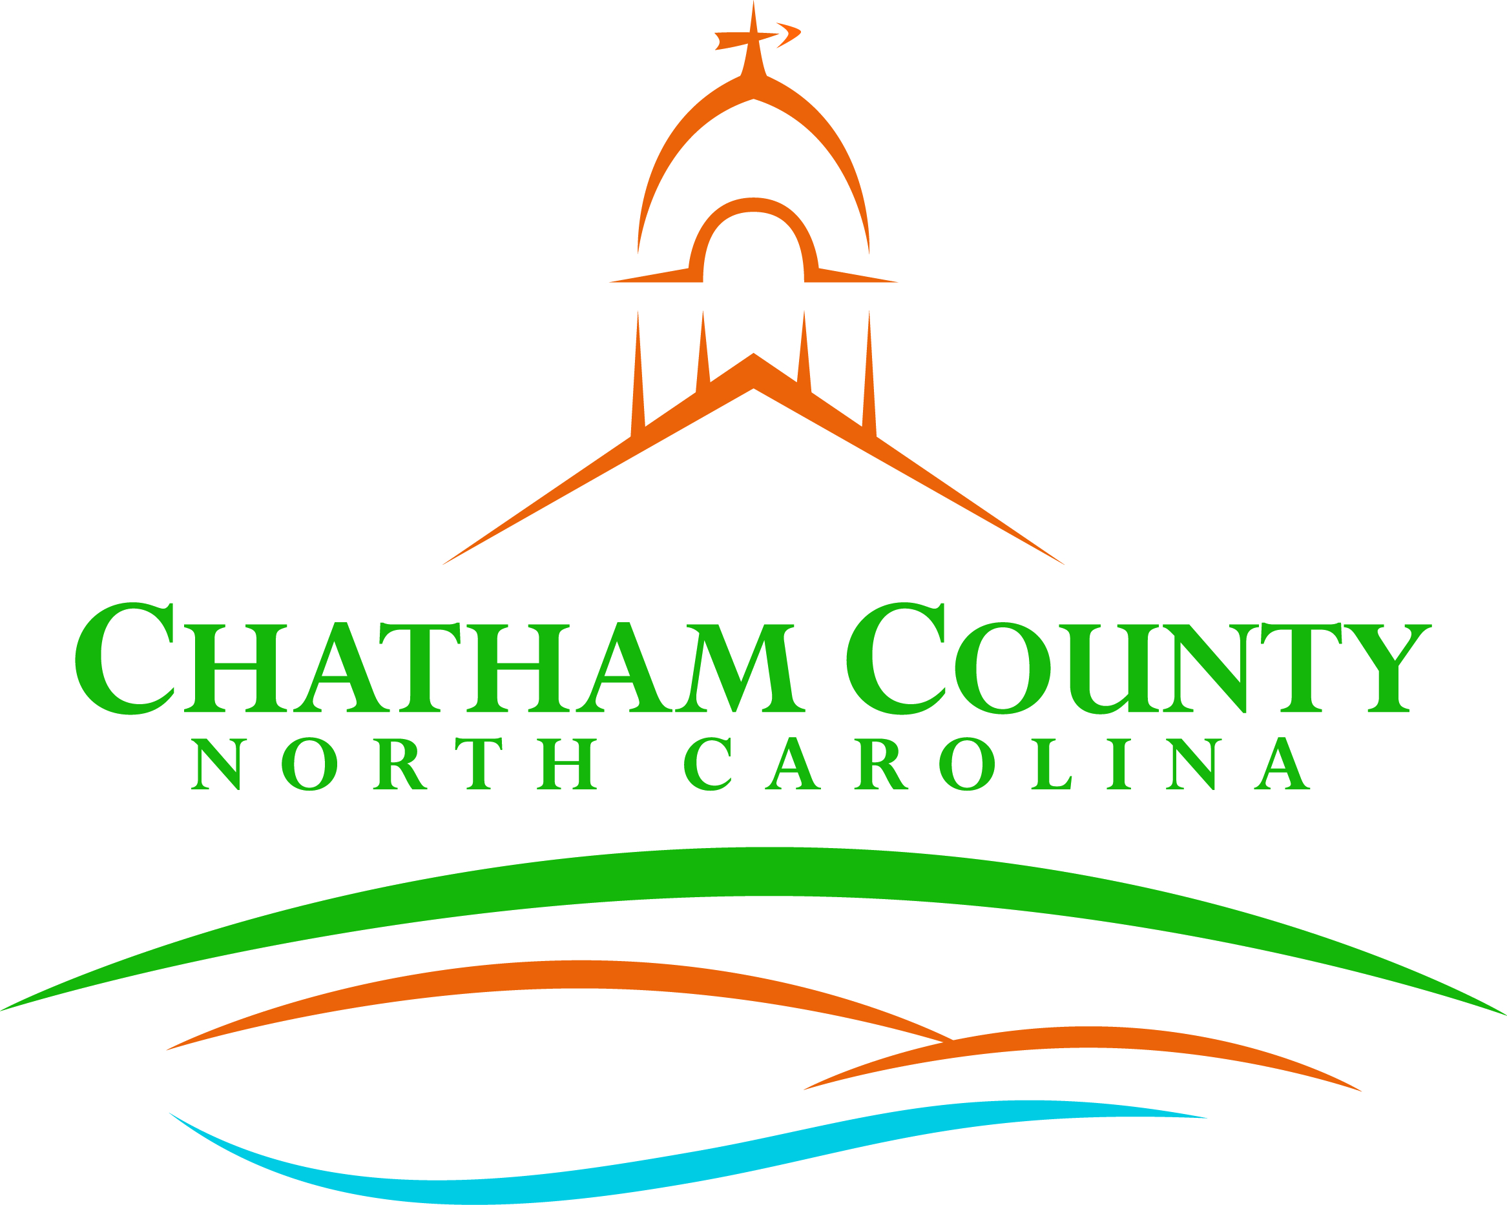
Dan LaMontagne
P. O. Box 1809, Pittsboro, NC 27312-1809 ● Phone: (919) 542-8200
Established 1771
Mike Dasher, Chair
Diana Hales, Vice Chair
Jim Crawford
Franklin Gomez Flores
Karen Howard
CHATHAM COUNTY COMMISSIONERS COUNTY MANAGER

Resolution of the Chatham County Board of Commissioners

RECOGNIZING WEDNESDAY, SEPTEMBER 15, 2021
AS CHATHAM COUNTY’S UNITED WAY DAY OF SERVICE

WHEREAS, residents across the county come together in a remarkable spirit of unity and carry out countless acts of kindness, generosity, and compassion; and

WHEREAS, September 15, 2021 United Way Day of Service activities are being organized by a variety of nonprofits, faith-based and community groups, public agencies, educational institutions, private businesses, and other organizations across the County; and

WHEREAS, on September 15, 2021, and on the days leading up to and following this day, residents of Chatham County, North Carolina have an opportunity to participate in activities that promote volunteerism by joining together in service projects to meet community needs.

NOW THEREFORE BE IT RESOLVED by the Chatham County Board of Commissioners in North Carolina proclaims September 15th, a Day of Service in Chatham County, North Carolina, and calls upon the people of Chatham County, North Carolina to participate in community service on this day and throughout the year.

Adopted this, the 16th day of August, 2021.

_______________________
Mike Dasher, Chairman

___________________ _______________________
Diana Hales, Vice Chair Jim Crawford, Commissioner

___________________ _______________________
Franklin Gomez Flores, Commissioner Karen Howard, Commissioner

