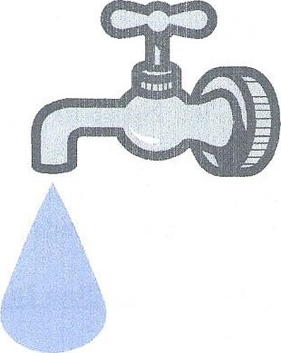

**Goldston-Gulf   
Sanitary District** **Town of Goldston**

**Sign Off for New Water and Sewer Connection**

|  |  |
| --- | --- |
| **PAR :** |  |

|  |  |  |  |
| --- | --- | --- | --- |
| **Last Name :** |  | **First Name :** |  |

|  |  |
| --- | --- |
| **Street Address:** |  |

|  |  |  |  |  |  |
| --- | --- | --- | --- | --- | --- |
| **City :** |  | **State :** |  | **Zip Code :** |  |

Site Plan/Application Approved

Type of Structure:  Detached  Modular  Dbl. Wide  Single Wide  Commercial

Goldston Impact Fee paid

Sewer Tap Fee paid

Water Tap Fee paid

Water Meter Installed

If well exist, disconnected from dwelling

Sewer Tap installed

X

**G-GSD Approval Date**

X

**Town of Goldston Approval Date**