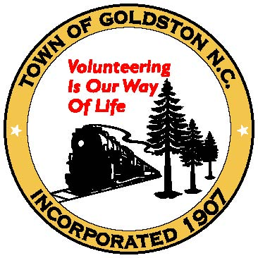 **Town of Goldston**

**C/O Chatham County Planning Department PO Box 54**

**Pittsboro NC 27312**

**(Ph) 919-542-8204 (Fax) 919-542-2698**

**HOME OCCUPATION PERMIT APPLICATION**

Type: Please check one: Neighborhood  Rural (Requires 3 ac minimum)

(1) Applicant Information (2) Landowner Information

Name Name

Address Address

Ph: (H) Ph: (H)

(W) (W)

(M) (M)

**(If applicant is different from landowner, please provide signed legal representation authorization form)**

(3) Property Identification:

911 Address Parcel # _______________

Zoning District ___________

Township Acreage

Flood Map # Flood Zone (11-17-2017)

Watershed   
Deed Book ______ Page ______ Year Plat Book _______ Page ______

(4) Directions to Property

(5) Describe the type of occupation/business to be operated from the property. Also list any equipment to be used in the occupation.

(6) Will non-resident employees be using the property to work or to gather materials and/or tools of the trade? Yes how many? No

(7) Will the business be carried on inside the residence or in an accessory building? If accessory building, what is the total square footage? __________ (**Please provide a site plan detailing the location of the building from all property lines and access)**

(8) Will the general public be coming to the property to receive services or purchase product from this business? Yes No

(9) If #6 and #8 are yes, how many parking spaces will be provided and where will they be located?

(10) Will the occupation be advertised by a sign?

(11) If the answer to # 10 is yes, where will the sign be located? **(Note: Signage must be no larger than 4 sq. ft. and must be located outside the NCDOT right-of-way on the same property with the home-based business**)

(12) Will there be any noise, glare, vibration, odors, or electrical interference associated with your home occupation?

(13) If the answer to # 12 is yes, please describe noise, etc. and how it will be controlled so it will not be a nuisance.

This permit is valid only as long as the use meets the provisions for home occupations specified in the Town of Goldston Unified Development Ordinance and may be revoked any time the use does not meet these provisions or other applicable ordinances. The permit is not transferable.

**In addition to compliance with the Town of Goldston Unified Development Ordinance regarding operating a home-based business/home occupation, I understand I may also be required to comply with other local, state, or federal laws, rules, ordinances that pertain to the operation of this business/occupation BEFORE beginning said business/occupation.**

I hereby certify that I am making application for the landowner or myself and that the statements given are true to the best of my knowledge. **Please return this permit to the Planning Department in person along with a $100.00 fee.**

Signature of Applicant Date

Signature of Landowner (if applicable) Date



To be completed by the Planning Department.

Granted __________ Denied __________

Comments:

Planning Department: Date



NCDOT Approval Yes No Rcv’d

Chatham County Environmental Health Approval Yes No Rcv’d

Chatham County Building Inspections Approval Yes No Rcv’d

Chatham County Fire Marshal Approval Yes No Rcv’d

Chatham County Erosion Control Approval Yes No Rcv’d

Chatham County Stormwater Approval Yes No Rcv’d