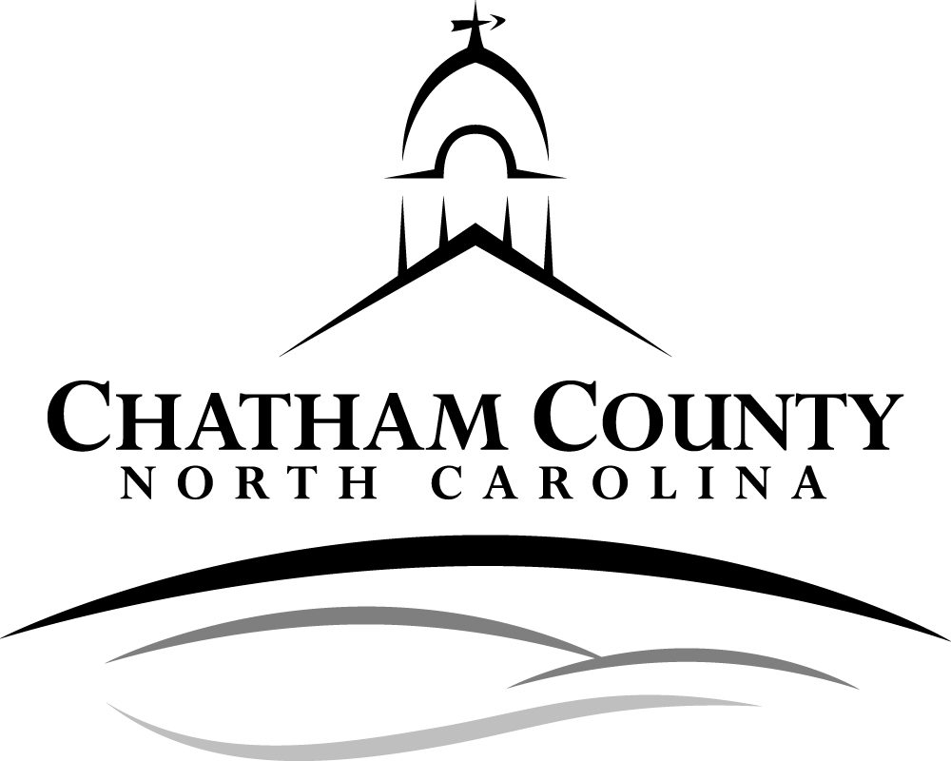
Steps to Starting a Business in Chatham County
Pre-Application Meeting (optional)
The intent of the pre-application meeting is to prepare applicants for the permitting process and provide technical guidance to assist them in determining which local and/or state regulations may apply and what steps must be taken in order to obtain approvals.

Please note that the scope of your project will determine which steps you need to take.

Step 1 Chatham County Planning Department, 919-542-8204
Information needed: parcel number and proposed type of business
Determine Jurisdiction (Pittsboro or Chatham County)
Zoning Determination
Flood Plain Determination
Watershed District Determination
Riparian Buffer Review

Step 2 Environmental Health Division, 919-542-8208
Information needed: flood plain determination, riparian buffer review, zoning determination, Environmental Health site plan and type of business including proposed water use. (For questions about determining water use contact Environmental Health at 542-8208)
Improvement Permit for septic system
If the proposed business is a child care, food service, institution, lodging, etc. verify with Chatham County Environmental Health Food and Lodging Section that no other government agencies need to issue licenses or other approvals (i.e. Division of Child Development, Public Water Supply)

Step 3 Emergency Operations Center, 919-545-8161
Information needed: parcel number
911 Addressing

Step 4 Environmental Health Division, 919-542-8208
Information needed: Improvement Permit for septic system and 911 address
Construction Authorization for septic system
Well Permit (Application & Fee) if city/county water is not available

Step 5 The following may be completed concurrently

- Erosion Control, 919-545-8343
Information Needed: Grading plan
Land Disturbance Permit (for projects disturbing over 20,000 sq ft)

- Environmental Quality Department, 919-545-8531
Information Needed: Stormwater Mgmt. Plan and Site Plan with Built-upon area noted and surface waters identified
Stormwater Review (for projects disturbing over 20,000 sq ft)
Built-upon area Review

- NC Department of Transportation, 336-318-4000
Information Needed: Application submitted to NCDOT and Approval letter
Commercial Driveway entrance permit

- Planning Department, 919-542-8204
Information needed: Site Plan that shows structure locations, landscaping, parking, signage, access, and lighting
Site Plan Review permit
Appearance Commission Review, if applicable
Signing and lighting plans application, if applicable

Step 6 The following may be completed concurrently

Information REQUIRED: Completed commercial building permit application, building plans, and documents proving that potable water and septic/sewer are available to the property (i.e. receipt from County Water Dept, well permit, construction authorization for septic system, copy of State sewer permit). *New development projects are required to connect to the County water system if water service is determined to be available and feasible as defined by the Chatham County Water Department. Chatham County Water Department, 919 542-8270
- Building Inspections and Fire Marshal Department, 919 542-8230
Commercial Building Plan Review (2 hard copies and 1 PDF format, include one copy of Appendix B, and a site plan)
- Environmental Health Division, 919 542-8208
Establishment Plan Review and approval (if business is a regulated establishment (i.e. food service, child care, lodging, institutions etc.)
c. Solid Waste and Recycling Division, 919 542-5516, (if greater than 1,000 sq ft)
Construction and Demolition Recycling Document

The END – Building permit issued

